Contents

*1.**About the team 2*

*2.**About the project 2*

*3.**Main stages – Sprint log 3*

*4.**Used technologies 3*

*5.**Diagrams 4*

StudyPilot



# About the team

|  |  |  |
| --- | --- | --- |
| Team member | Role | Class |
| Kristiyan Kostadinov | Project manager | XI G |
| Stiliyan Georgiev | Project manager | XI G |
| Teodor Tanev | Back-end developer | XI G |
| Mariela Dimova | Back-end developer | XI G |
| Stiliyan Mishev | Designer | XI G |
| Lyubo Dimov | Designer | XI G |

# About the project

This is a Flask-based web application designed to help students and young professionals discover internship opportunities tailored to their preferences and skills. The platform allows users to:

* Register and verify their identity via email
* Fill out a detailed survey to specify interests, skills, availability, and education level
* Get matched with internships offered by various companies across different industries (e.g., IT, Marketing, Finance, Education)
* Choose between remote, on-site, or hybrid internships
* Explore company types (startups, medium-sized, or large corporations)

# Main stages – Sprint log

|  |  |
| --- | --- |
| Week | Activities |
| First week | Task coordination among team members, initial Word documentation draft, GitHub repository setup, design custom logo, create README file. |
| Second week | Creation of UML diagrams, design Agile-based user stories, draft questionnaire questions. |
| Third week | Develop questionnaire web page, develop login and registration system. |
| Fourth week | Implement company registration functionality, develop profile editing feature, implement student-teacher role system. |
| Fifth week | Implement other users’ profile view, develop post creation functionality on profile pages, integrate AI model for internship recommendations. |
| Sixth week | Develop admin dashboard features, enhance company-related functionalities, create unit tests for key functionalities. |
| Seventh week | |  | | --- | | Prepare final PDF report, finalize sprint logs, create presentation. | |

# Used technologies

**Python** – used as the main programming language for backend development.

**Flask** – a lightweight web framework used to handle routing, templating, and server-side logic.

**Flask-Mail** – used for sending emails (e.g., confirmation codes and notifications).

**Flask-Bootstrap** – used to integrate Bootstrap with Flask for responsive UI components and layout.

**Flask-WTF** – used to manage web forms with CSRF protection and easy field validation.

**Flask-SQLAlchemy** – used as the Object Relational Mapper (ORM) to interact with the relational database in a Pythonic way.

**WTForms** – used to create and manage complex form structures and validation rules.

**Jinja2** – the templating engine used to dynamically generate HTML pages from Python backend logic.

**HTML5 & CSS3** – used to structure and style the frontend of the website with semantic elements and modern responsive design.

**Git & GitHub** – used for version control, collaborative development, and cloud-based repository management.

**Microsoft Office 365** – used for documentation, planning, and report preparation.

**PyCharm** – used as the primary integrated development environment (IDE) for writing, testing, and debugging Python code.

**Microsoft Azure** – used for hosting the web application and managing its backend services and database.

**Blender** – used to design and create 3D models and visual content where applicable.

# Diagrams

* Entity Relationship diagram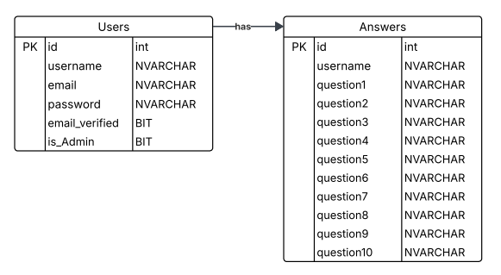
* UML Class Diagram

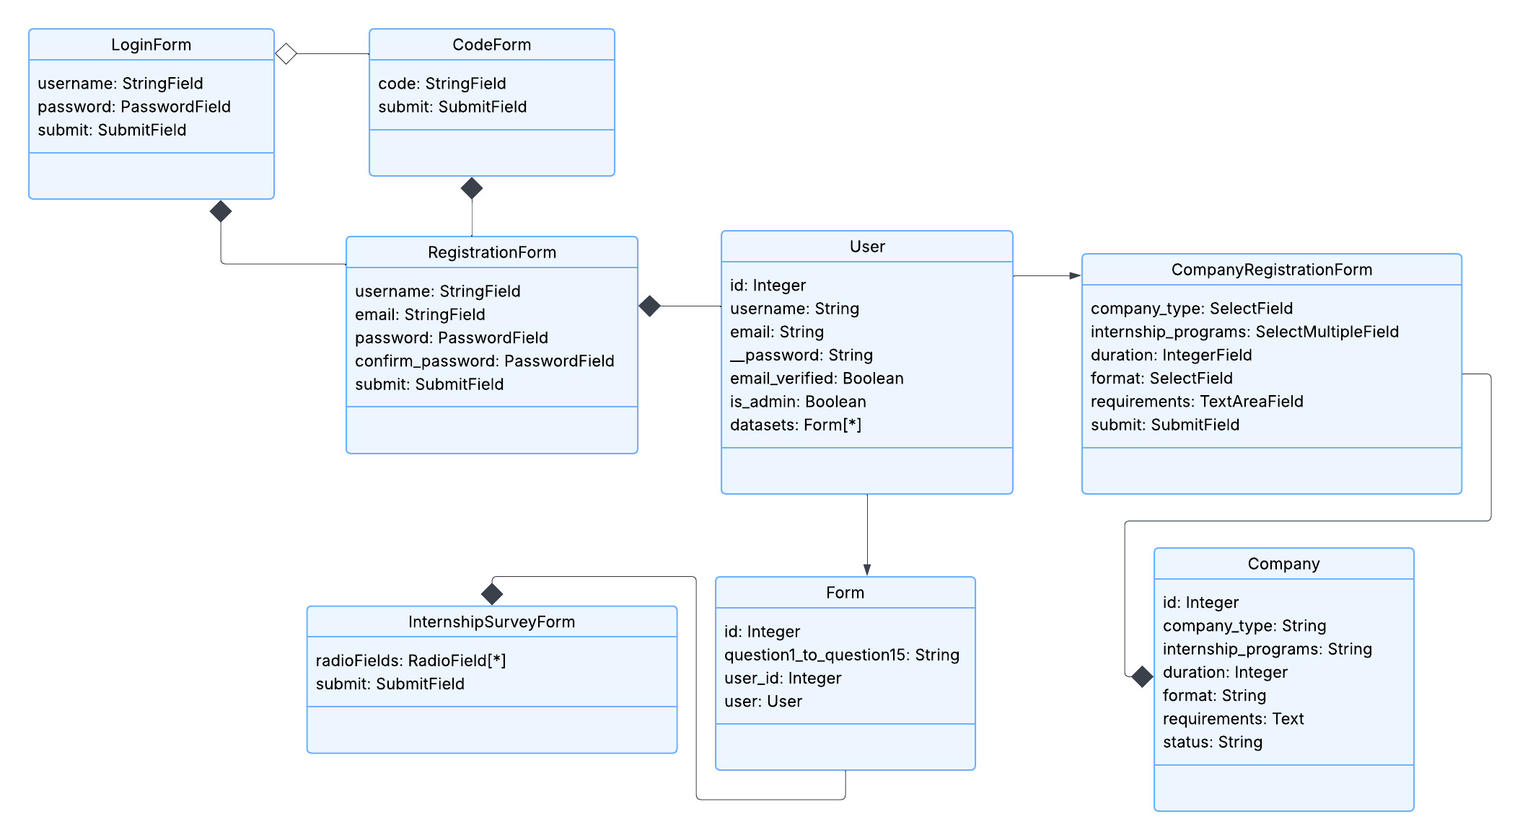

* UML Use case diagram

